TABLE OF CONTENTS

ABSTRACT | i
LIST OF FIGURES | iii
1. INTRODUCTION | 4
1.1INTRODUCTION ABOUT PROBLEM | 4
1.2INTRODUCTION ABOUT EXISTING SYSTEM | 4
1.3INTRODUCTION ABOUT PROPOSED SYSTEM | 5
2. LITERATURERE VIEW | 6
3. EXISTING SYSTEM AND PROBLEM STATEMENT | 10
3.1 EXISTING SYSTEM | 10
3.2 PROBLEM STATEMENT | 10
4. PROPOSED SYSTEM AND ARCHITECTURE | 12
4.1 PROPOSED SYSTEM | 12
4.2 SYSTEM ARCHITECTURE | 14
5. SYSTEM REQUIREMENTS AND DESIGN | 16
5.1 SYSTEM REQUIREMENTS | 16
5.2 SYSTEM DESIGN | 17
6. SYSTEM IMPLEMENTATION | 26
6.1 DATA SOURCE | 26
6.2 DATA PREPROCESSING | 26
6.3MODEL EVALUATION | 27
7. RESULTS AND DISCUSSION | 28
8. CONCLUSION | 30
9. FUTURE ENHANCEMENTS | 31
10. REFERENCES | 32
11. APPENDIX | 33
11.1 CODE | 33
11.2 OUTPUT SCREENS | 44

ABSTRACT
Computer networks intrusion detection systems (IDSs) and intrusion prevention systems (IPSs) are critical aspects that contribute to the success of an organization. Over the past years, IDSs and IPSs using different approaches have been developed and implemented to ensure that computer networks within enterprises are secure, reliable and available. In this paper, we focus on IDSs that are built using machine learning (ML) techniques. IDSs based on ML methods are effective and accurate in detecting networks attacks. However, the performance of these systems decreases for high dimensional data spaces. Therefore, it is crucial to implement an appropriate feature extraction method that can prune some of the features that do not possess a great impact in the classification process. Moreover, many of the ML based IDSs suffer from an increase in false positive rate and a low detection accuracy when the models are trained on highly imbalanced datasets. In this paper, we present an analysis the UNSW-NB15 intrusion detection dataset that will be used for training and testing our models. Moreover, we apply a flter-based feature reduction technique using the XGBoost algorithm. We then implement the following ML approaches using the reduced feature space: Support Vector Machine (SVM), k-Nearest-Neighbour (kNN), Logistic Regression (LR), Artifcial Neural Network (ANN), Decision Tree (DT) and Convolutional Neural Networks (CNN). In our experiments, we considered both the binary and multiclass classification configurations. The results demonstrated that the XGBoost-based feature selection method allows for methods such as the DT to increase its test accuracy the binary classification scheme.
Keywords: Machine learning, Feature engineering, Computer networks, Intrusion detection.

INTRODUCTION
1.1 INTRODUCTION ABOUT PROBLEM
The increasing reliance on digital technologies such as the Internet and Internet of Things (IoT) has led to significant growth in cyber threats. Hackers are continuously evolving their techniques, making it harder for traditional security systems to keep up. Intrusion Detection Systems (IDSs) play a crucial role in identifying and mitigating these threats by monitoring network traffic and system activities. However, traditional IDS approaches often struggle with low detection accuracy, high false positives, and are ineffective against new or sophisticated attacks.
As cyber-attacks become more complex, there is a need for more intelligent, adaptive systems that can efficiently detect and respond to intrusions. The limitations of existing methods highlight the need for a solution that can improve detection accuracy, reduce false alarms, and perform well in real-time environments.
1.2 INTRODUCTION ABOUT EXISTING SYSTEM
To protect computer networks from attacks, Intrusion Detection and Prevention Systems (IDS/IPS) are used. These systems monitor network or device activity to detect suspicious behaviour.
There are several types of IDS/IPS in use:
- Network-Based Systems (e.g., Snort, Suricata, Zeek): Monitor network traffic for known attack patterns.
- Host-Based Systems (e.g., OSSEC, Malware Defender): Installed on individual devices to detect threats on that specific machine.
- Hybrid Systems (e.g., Prelude OSS): Combine both network and host monitoring.
- AI-Based Systems (e.g., Vectra AI): Use machine learning to detect new and unknown attacks.

1.3 INTRODUCTION ABOUT PROPOSED SYSTEM

To address the limitations of the existing methods, the proposed system introduces an enhanced Intrusion Detection System using machine learning algorithms, including Decision Tree, k-Nearest Neighbour (kNN), Logistic Regression (LR), Convolutional Neural Networks (CNN) and XGBoost. Among these, the Decision Tree algorithm is chosen for its simplicity, faster training time, interpretability, and high accuracy.

The proposed system leverages the strengths of these ML models to analyze system behaviour and accurately classify whether a network event is benign or malicious. By using efficient classification techniques and feature selection methods, the system not only improves performance but also significantly reduces the time required to detect threats.

This approach ensures that the IDS is capable of operating in real-time environments while maintaining a high level of precision and ease of deployment.

LITERATURE REVIEW

- Ribeiro J, Saghezchi FB, Mantas G, Rodriguez J, Abd-Alhameed RA. Hidroid: prototyping a behavioral host-based intrusion detection and prevention system for android. IEEE Access. 2020;8:23154–168.
Previous research efforts on developing an Intrusion Detection and Prevention Systems (IDPS) for Android mobile devices rely mostly on centralized data collection and processing on a cloud server. However, this trend is characterized by two major limitations. First, it requires a continuous connection between monitored devices and the server, which might be infeasible, due to mobile network’s outage or partial coverage. Second, it increases the risk of sensitive information leakage and the violation of user’s privacy. To help alleviate these problems, in this paper, we develop a novel Host-based IDPS for Android (HIDROID), which runs completely on a mobile device, with a minimal computation burden. It collects data in run-time, by periodically sampling features reflecting the utilization of scarce resources on a mobile device (e.g. CPU, memory, battery, bandwidth, etc.). The detection engine exploits statistical and machine learning algorithms to build a data-driven model for the benign behaviour. Any observation failing to match this model triggers an alert, and the preventive agent takes proper countermeasure(s) to minimize the risk. HIDROID requires no malicious data for training or tuning, which makes it handy for day-to-day usage. Experimental test results, on a real-life device, show that HIDROID is well able to learn and discriminate normal from malicious behaviour, with very promising accuracy of up to 0.9, while maintaining false positive rate by 0.03.

- Van NTT, Thinh TN. Accelerating anomaly-based IDS using neural network on GPU. In: 2015 international conference on advanced computing and applications (ACOMP). IEEE; 2015. pp. 67–74.
Recently, anomaly-based intrusion detection system (IDS) is valuable methodology to protect target systems and networks against attacks. Modelling normal system/network behaviors enables anomaly-based IDS (Intrusion Detection System) to be extremely effective methodology to detect both known as well as unknown/new attacks. However, current software-based methods are difficult to process a large amount of data in anomaly-based IDSs and cannot keep up the high-link speeds. The implementations of anomaly-based IDSs on parallel processing platforms are considered as necessary to accelerate speed of the systems. Neural Networks are a good example of parallel computing. In this paper, we used Neural Network technology to classify normal or abnormal behaviours. The parallel nature of Neural Networks has been implemented on GPUs that allows the system to meet a set of requirements such as time constraints management, robustness, high processing speed and re-configurability. Experiments with KDD Cup 1999 network traffic connections which have been pre-processed with methods of features selection and normalization have shown that our work is effective to accelerate intrusion detection in anomaly-based IDS. The result shows that our implementation on GPU is much faster than the implementation on CPU up to 32x.

- Jabez J, Muthukumar B. Intrusion detection system (IDS): anomaly detection using outlier detection approach. Procedia Comput Sci. 2015;48:338–46.
Abstract an Intrusion Detection System (IDS) is a software application or device that monitors the system or activities of network for policy violations or malicious activities and generates reports to the management system. A number of systems may try to prevent an intrusion attempt but this is neither required nor expected of a monitoring system. The main focus of Intrusion detection and prevention systems (IDPS) is to identify the possible incidents, logging information about them and in report attempts. In addition, organizations use IDPS for other purposes, like identifying problems with security policies, deterring individuals and documenting existing threats from infringing security policies. IDPS have become an essential addition to the security infrastructure of nearly every organization. Various methods can be used to detect intrusions but each one is specific to a specific method. The main goal of an intrusion detection system is to detect the attacks efficiently. Furthermore, it is equally important to detect attacks at a beginning stage in order to reduce their impacts. This research work proposed a new approach called outlier detection where, the anomaly dataset is measured by the Neighbourhood Outlier Factor (NOF). Here, trained model consists of big datasets with distributed storage environment for improving the performance of Intrusion Detection system. The experimental results proved that the proposed approach identifies the anomalies very effectively than any other approaches.

- Neelakantan S, Rao S. A threat-aware anomaly-based intrusion-detection approach for obtaining network-specifc useful alarms. In: International conference on distributed computing and networking. Springer. 2009; pp. 175–180.
We present a model and architecture that enhance anomaly based intrusion detection system(IDS) with threat-awareness capability. Anomaly based network IDS, profile network traffic to arrive base-line based on which it identifies anomalous events. However, due to dynamic changes in the threat level of a network, only a subset of these identified events are relevant to the network at any given instance. Hence, we introduce the notion of Threat-Awareness for anomaly based network IDS that periodically learns the changing threats in a network and enhance the capability of traditional anomaly based IDS to obtain network specific useful alarms. In this paper, we present a Threat-Aware Anomaly-Based IDS model for obtaining network-specific useful alarms. We also present our architecture and discuss its internal functions. Finally, we present our experiments based on various threat scenarios and the results obtained proves the efficiency of our model.

- Zhu Z, Ong Y-S, Dash M. Wrapper-flter feature selection algorithm using a memetic framework. IEEE Trans Sys Man Cybern Part B (Cybern). 2007;37(1):70–6
This correspondence presents a novel hybrid wrapper and filter feature selection algorithm for a classification problem using a memetic framework. It incorporates a filter ranking method in the traditional genetic algorithm to improve classification performance and accelerate the search in identifying the core feature subsets. Particularly, the method adds or deletes a feature from a candidate feature subset based on the univariate feature ranking information. This empirical study on commonly used data sets from the University of California, Irvine repository and microarray data sets shows that the proposed method outperforms existing methods in terms of classification accuracy, number of selected features, and computational efficiency. Furthermore, we investigate several major issues of memetic algorithm (MA) to identify a good balance between local search and genetic search so as to maximize search quality and efficiency in the hybrid filter and wrapper MA

EXISTING METHOD
The increasing growth of machine learning, computer techniques divided into traditional methods and machine learning methods. This section describes the related works of performance of Intrusion Detection systems and how machine learning methods are better than traditional methods. The existing method in this project have a certain flow is used for model development. SVM and ANN are used algorithms in existing system. But it requires large memory and result is not accurate.
Disadvantages:
1. Accuracy low
2. Requires more time
3. Difficult to handle

PROBLEM STATEMENT
With the rapid growth of the internet and increasing dependence on digital systems, cybersecurity threats such as unauthorized access, data breaches, and malicious attacks are becoming more frequent and complex. Traditional intrusion detection systems (IDS), which rely on signature-based or rule-based methods, often fail to detect new or unknown attacks due to their static nature.
To address this issue, there is a growing need for intelligent, adaptive systems that can accurately identify both known and unknown intrusions in real-time. Machine learning (ML) provides a promising approach by enabling systems to learn from historical data and recognize complex patterns of attack behavior.
In this project, we aim to develop an effective intrusion detection system using various machine learning algorithms such as K-Nearest Neighbors (KNN), Logistic Regression, Artificial Neural Networks (ANN), Convolutional Neural Networks (CNN), Support Vector Machines (SVM), XGBoost, and Decision Trees. These models will be trained and evaluated on benchmark intrusion detection datasets to:
- Improve detection accuracy
- Reduce false positive rates
- Minimize computational overhead
- Enhance the system’s ability to detect novel attacks
The goal is to compare these algorithms to identify the most efficient and reliable model for real-time intrusion detection.

PROPOSED SYSTEM
Much research has been done on studying performance analysis of intrusion detection of systems. In early days if have to check the system performance it’s a time taking process. We can detect the system performance by using Decision tree, KNN (K-Nearest Neighbour), LG (Logistic Regression), Decision Tree, XGBoost. To get better accuracy we used Decision Tree algorithm. Bu using these machine learning techniques we can easily detect the system performance like weather the system is attacked or not.
Advantages:
1. Requires less time
2. Good Accuracy
3. Easy to handle
Block Diagram:
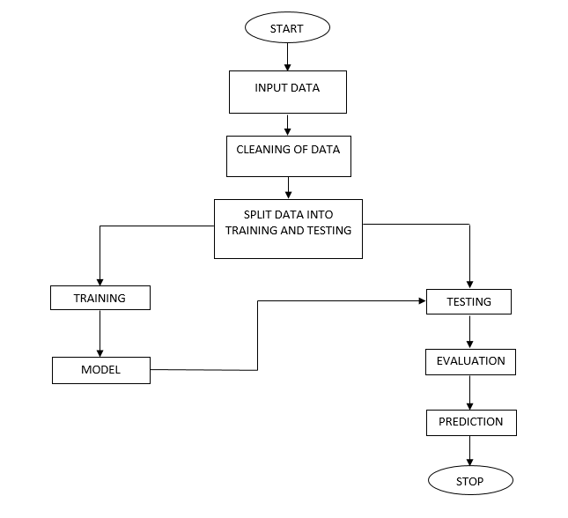
Fig 1. Block Diagram of Proposed System
ARCHITECTURE

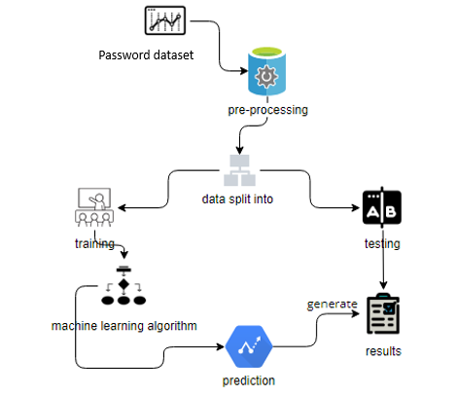
Fig. Architecture diagram

SYSTEM REQUIREMENTS
Functional and non-functional requirements:
Requirement’s analysis is very critical process that enables the success of a system or software project to be assessed. Requirements are generally split into two types: Functional and non-functional requirements.
Functional Requirements: These are the requirements that the end user specifically demands as basic facilities that the system should offer. All these functionalities need to be necessarily incorporated into the system as a part of the contract. These are represented or stated in the form of input to be given to the system, the operation performed and the output expected. They are basically the requirements stated by the user which one can see directly in the final product, unlike the non-functional requirements.
Examples of functional requirements:
- Authentication of user whenever he/she logs into the system
- System shutdown in case of a cyber-attack
- A verification email is sent to user whenever he/she register for the first time on some software system.
Non-functional requirements: These are basically the quality constraints that the system must satisfy according to the project contract. The priority or extent to which these factors are implemented varies from one project to other. They are also called non-behavioral requirements.
They basically deal with issues like:
- Portability
- Security
- Maintainability
- Reliability
- Scalability
- Performance
- Reusability
- Flexibility
Examples of non-functional requirements:
- Emails should be sent with a latency of no greater than 12 hours from such an activity.
- The processing of each request should be done within 10 seconds
- The site should load in 3 seconds whenever of simultaneous users are > 10000
H/W Configuration:
• Processor - I3/Intel Processor
• Hard Disk -160 GB
• RAM - 8 GB
S/W Configuration:
• Operating System : Windows 7/8/10 .
• Server side Script : HTML, CSS & JS.
• IDE : Pycharm.
• Libraries Used : Numpy, IO, OS, Flask, keras.
• Technology : Python 3.6+.

MODULES
1. System:
1.1 Store Dataset:
The System stores the dataset given by the user.
1.2 Model Training:
The system takes the data from the user and fed that data to the selected model.
1.3 Model Predictions:
The system takes the data given by the user and predict the output based on the given data.
1.4 Data Splitting:
Here the system can split the data into two parts for training and testing.
2. User:
2.1 Register:
Users can register for the Performance Analysis of Intrusion Detection Systems Using a Feature Selection Method application here.
2.2 Login:
After registering, the user can access his portal.
2.3 Load Dataset:
The user can upload the dataset he/she want to work on.
2.4 View Dataset:
The User can view the dataset.
2.5 Select model:
User can apply the model to the dataset for accuracy.
2.6 View results:
User can view the predicted results weather the system is attacked or not.

ALGORITHMS

Decision Tree:
- Decision tree learning is a supervised machine learning technique for inducing a decision tree from training data. A decision tree (also referred to as a classification tree or a reduction tree) is a predictive model which is a mapping from observations about an item to conclusions about its target value.
- The goal of using a Decision Tree is to create a training model that can use to predict the class or value of the target variable by learning simple decision rules inferred from prior data (training data). In Decision Trees, for predicting a class label for a record we start from the root of the tree.

K-Nearest Neighbour:
- K-Nearest Neighbour is one of the simplest Machine Learning algorithms based on Supervised Learning technique.
- K-NN algorithm assumes the similarity between the new case/data and available cases and put the new case into the category that is most similar to the available categories.
- K-NN algorithm stores all the available data and classifies a new data point based on the similarity. This means when new data appears then it can be easily classified into a well suite category by using K- NN algorithm.
- K-NN algorithm can be used for Regression as well as for Classification but mostly it is used for the Classification problems.
- K-NN is a non-parametric algorithm, which means it does not make any assumption on underlying data.
- It is also called a lazy learner algorithm because it does not learn from the training set immediately instead it stores the dataset and at the time of classification, it performs an action on the dataset.
- KNN algorithm at the training phase just stores the dataset and when it gets new data, then it classifies that data into a category that is much similar to the new data.
- Example: Suppose, we have an image of a creature that looks similar to cat and dog, but we want to know either it is a cat or dog. So for this identification, we can use the KNN algorithm, as it works on a similarity measure. Our KNN model will find the similar features of the new data set to the cats and dogs images and based on the most similar features it will put it in either cat or dog category.

LOGISTIC REGRESSION:
Logistic Regression was used in the biological sciences in early twentieth century. It was then used in many social science applications. Logistic Regression is used when the dependent variable (target) is categorical.
For example,
To predict whether an email is spam (1) or (0)
Whether the tumor is malignant (1) or not (0)
Consider a scenario where we need to classify whether an email is spam or not. If we use linear regression for this problem, there is a need for setting up a threshold based on which classification can be done. Say if the actual class is malignant, predicted continuous value 0.4 and the threshold value is 0.5, the data point will be classified as not malignant which can lead to serious consequence in real time.
From this example, it can be inferred that linear regression is not suitable for classification problem. Linear regression is unbounded, and this brings logistic regression into picture. Their value strictly ranges from 0 to 1.
Purpose and examples of logistic regression:
Logistic regression is one of the most commonly used machine learning algorithms for binary classification problems, which are problems with two class values, including predictions such as “this or that,” “yes or no” and “A or B.”
The purpose of logistic regression is to estimate the probabilities of events, including determining a relationship between features and the probabilities of particular outcomes.
One example of this is predicting if a student will pass or fail an exam when the number of hours spent studying is provided as a feature and the variables for the response has two values: pass and fail.
Organizations can use insights from logistic regression outputs to enhance their business strategies so they can achieve their business goals, including reducing expenses or losses and increasing ROI in marketing campaigns, for example.
An e-commerce company that mails expensive promotional offers to customers would like to know whether a particular customer is likely to respond to the offers or not. For example, they’ll want to know whether that consumer will be a “responder” or a “non responder.” In marketing, this is called propensity to respond modeling.
Likewise, a credit card company develops a model to decide whether to issue a credit card to a customer or not will try to predict whether the customer is going to default or not on the credit card based on such characteristics as annual income, monthly credit card payments and number of defaults. In banking parlance, this is known as default propensity modeling.
Uses of logistic regression:
Logistic regression has become particularly popular in online advertising, enabling marketers to predict the likelihood of specific website users who will click on particular advertisements as a yes or no percentage.
- Logistic regression can also be used in:
- Healthcare to identify risk factors for diseases and plan preventive measures.
- Weather forecasting apps to predict snowfall and weather conditions.
- Voting apps to determine if voters will vote for a particular candidate.
Insurance to predict the chances that a policy holder will die before the term of the policy expires based on certain criteria, such as gender, age and physical examination.
Banking to predict the chances that a loan applicant will default on a loan or not, based on annual income, past defaults and past debts.
Logistic regression vs. linear regression:
The main difference between logistic regression and linear regression is that logistic regression provides a constant output, while linear regression provides a continuous output.
In logistic regression, the outcome, such as a dependent variable, only has a limited number of possible values. However, in linear regression, the outcome is continuous, which means that it can have any one of an infinite number of possible values.
Logistic regression is used when the response variable is categorical, such as yes/no, true/false and pass/fail. Linear regression is used when the response variable is continuous, such as number of hours, height and weight.
XGBoost:
XGBoost stands for “Extreme Gradient Boosting”. XGBoost is an optimized distributed gradient boosting library designed to be highly efficient, flexible and portable. It implements Machine Learning algorithms under the Gradient Boosting framework. It provides a parallel tree boosting to solve many data science problems in a fast and accurate way.

Boosting
Boosting is an ensemble learning technique to build a strong classifier from several weak classifiers in series. Boosting algorithms play a crucial role in dealing with bias-variance trade-off. Unlike bagging algorithms, which only controls for high variance in a model, boosting controls both the aspects (bias & variance) and is considered to be more effective.
Below are the few types of boosting algorithms:
- AdaBoost (Adaptive Boosting)
- Gradient Boosting
- XGBoost
- CatBoost
- Light GBM

XGBoost
XGBoost stands for eXtreme Gradient Boosting. It became popular in the recent days and is dominating applied machine learning and Kaggle competitions for structured data because of its scalability.
XGBoost is an extension to gradient boosted decision trees (GBM) and specially designed to improve speed and performance.

XGBoost Features
- Regularized Learning: Regularization term helps to smooth the final learnt weights to avoid over-fitting. The regularized objective will tend to select a model employing simple and predictive functions.
- Gradient Tree Boosting: The tree ensemble model cannot be optimized using traditional optimization methods in Euclidean space. Instead, the model is trained in an additive manner.
- Shrinkage and Column Subsampling: Besides the regularized objective, two additional techniques are used to further prevent over fitting. The first technique is shrinkage introduced by Friedman. Shrinkage scales newly added weights by a factor η after each step of tree boosting. Similar to a learning rate in stochastic optimization, shrinkage reduces the influence of each tree and leaves space for future trees to improve the model.
The second technique is the column (feature) subsampling. This technique is used in Random Forest. Column sub-sampling prevents over-fitting even more so than the traditional row sub-sampling. The usage of column sub-samples also speeds up computations of the parallel algorithm.

Artificial Neural Networks (ANN):
ANN stands for Artificial Neural Network. It is one of the most basic types of neural networks and is widely used for classification, prediction, and pattern recognition problems. ANN is inspired by the biological neural networks of the human brain and is composed of layers of interconnected "neurons."
ANNs can learn from historical attack data and identify both known and unknown threats by recognizing underlying patterns in the network traffic. Their ability to adapt and generalize makes them a powerful tool in building intelligent intrusion detection systems.
Structure of ANN:
- Input Layer: Receives the initial data, such as extracted features from network traffic.
- Hidden Layers: One or more layers that perform intermediate computations and learn the relationship between input and output through weighted connections and activation functions.
- Output Layer: Produces the final classification—whether a particular input is an attack or normal behaviour.
Common Activation Functions:
- Sigmoid
- ReLU (Rectified Linear Unit)
- Tanh
Advantages of ANN in Intrusion Detection:
- Capable of modelling non-linear and complex relationships
- Learns from large datasets and improves over time
- Performs well on classification tasks such as binary (attack vs. normal) or multiclass intrusion categories
- Can be integrated with other ML models for hybrid detection systems

Convolutional Neural Networks (CNN):
CNN stands for Convolutional Neural Network. It is a class of deep neural networks most commonly applied to analyze visual imagery, but it has proven to be highly effective in intrusion detection as well, especially when working with spatial or temporal patterns in data. CNNs are inspired by the structure of the human visual cortex and are particularly known for their ability to capture hierarchical feature representations.
CNNs are powerful at automatically learning patterns and features from raw input data without the need for manual feature extraction. In intrusion detection systems, where large volumes of network traffic data must be analyzed, CNNs can be trained to identify complex attack signatures and anomalies.
Core Components of CNN:
- Convolutional Layer: Applies a set of filters (kernels) to the input data to extract important features such as edges, corners, or complex patterns.
- Activation Function (ReLU): Introduces non-linearity into the system, helping the network learn complex patterns.
- Pooling Layer: Reduces the spatial dimensions of the feature maps, leading to lower computational cost and prevention of overfitting.
- Fully Connected Layer: After several convolution and pooling layers, the output is flattened and passed to one or more dense layers for final classification.
Advantages of CNN in Intrusion Detection:
- Automatically extracts spatial features from raw data
- Capable of handling large-scale datasets
- Reduces the need for manual feature engineering
- Shows excellent performance in anomaly detection tasks

SYSTEM DESIGN:

Input Design:
In an information system, input is the raw data that is processed to produce output. During the input design, the developers must consider the input devices such as PC, MICR, OMR, etc.
Therefore, the quality of system input determines the quality of system output. Well-designed input forms and screens have following properties −
- It should serve specific purpose effectively such as storing, recording, and retrieving the information.
- It ensures proper completion with accuracy.
- It should be easy to fill and straightforward.
- It should focus on user’s attention, consistency, and simplicity.
- All these objectives are obtained using the knowledge of basic design principles regarding −
  - What are the inputs needed for the system?
  - How end users respond to different elements of forms and screens.

Objectives for Input Design:
The objectives of input design are
- To design data entry and input procedures
- To reduce input volume
- To design source documents for data capture or devise other data capture methods
- To design input data records, data entry screens, user interface screens, etc.
- To use validation checks and develop effective input controls.

Output Design:
The design of output is the most important task of any system. During output design, developers identify the type of outputs needed, and consider the necessary output controls and prototype report layouts.

Objectives of Output Design:
The objectives of input design are:
- To develop output design that serves the intended purpose and eliminates the production of unwanted output.
- To develop the output design that meets the end user’s requirements.
- To deliver the appropriate quantity of output.
- To form the output in appropriate format and direct it to the right person.
- To make the output available on time for making good decisions.

SYSTEM IMPLEMENTATION:
This section describes the step-by-step process of how the intrusion detection system was developed, from acquiring the dataset to building and deploying the model using various machine learning algorithms.
DATA SOURCE
- The dataset used in this project is the UNSW-NB15 dataset, which is widely used for evaluating intrusion detection systems. It contains a mix of normal and malicious network traffic records, making it ideal for training and testing machine learning models.
- The dataset was imported into the working environment in CSV format.
DATA PREPROCESSING
- The dataset was first loaded into the environment using Python.
- A check was performed to identify and handle any null or missing values.
- Once cleaned, the dataset was split into training and testing sets to prepare for model building.
- Several machine learning algorithms were applied to the training data, including:
  - K-Nearest Neighbours (KNN)
  - Logistic Regression
  - Support Vector Machine (SVM)
  - Artificial Neural Network (ANN)
  - Convolutional Neural Network (CNN)
  - Decision Tree
  - XGBoost
- Each model was trained and tested to compare their performance.

MODEL EVALUATION
- After evaluating all the models, the Decision Tree classifier achieved the best accuracy among the algorithms tested.
- The selected model was then integrated into a Flask-based web application for real-time intrusion detection.
- The user interface includes the following pages:
Home, About, Login, Registration, User Home Page, Upload Page, View Page, Preprocessing, Model Training, Prediction, and Graphs.
- Once a user uploads data and runs the model, the system detects whether the activity is an attack or normal, and provides a performance analysis graph to compare the models.

UML DIAGRAMS
UML stands for Unified Modelling Language. UML is a standardized general-purpose modelling language in the field of object-oriented software engineering. The standard is managed, and was created by, the Object Management Group.
The goal is for UML to become a common language for creating models of object-oriented computer software. In its current form UML is comprised of two major components: a Meta-model and a notation. In the future, some form of method or process may also be added to; or associated with, UML.
The Unified Modelling Language is a standard language for specifying, Visualization, Constructing and documenting the artifacts of software system, as well as for business modelling and other non-software systems.
The UML represents a collection of best engineering practices that have proven successful in the modelling of large and complex systems.
The UML is a very important part of developing objects-oriented software and the software development process. The UML uses mostly graphical notations to express the design of software projects.

GOALS:
The Primary goals in the design of the UML are as follows:
- Provide users a ready-to-use, expressive visual modelling Language so that they can develop and exchange meaningful models.
- Provide extendibility and specialization mechanisms to extend the core concepts.
- Be independent of particular programming languages and development process.
- Provide a formal basis for understanding the modelling language.
- Encourage the growth of OO tools market.
- Support higher level development concepts such as collaborations, frameworks, patterns and components.
- Integrate best practices.

USE CASE DIAGRAM
- A use case diagram in the Unified Modeling Language (UML) is a type of behavioral diagram defined by and created from a Use-case analysis.
- Its purpose is to present a graphical overview of the functionality provided by a system in terms of actors, their goals (represented as use cases), and any dependencies between those use cases.
- The main purpose of a use case diagram is to show what system functions are performed for which actor. Roles of the actors in the system can be depicted.
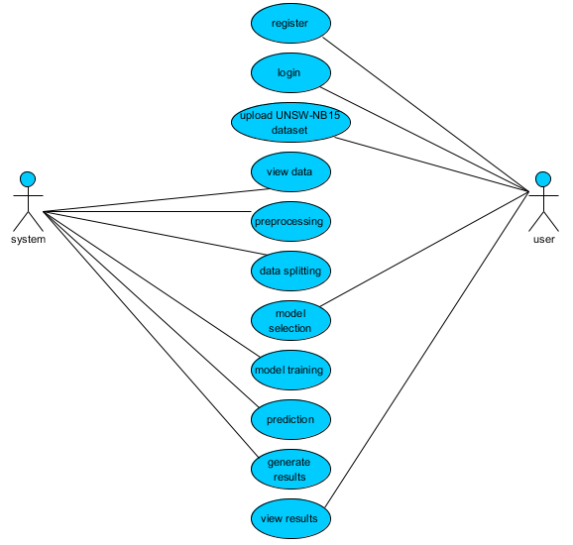

CLASS DIAGRAM
In software engineering, a class diagram in the Unified Modeling Language (UML) is a type of static structure diagram that describes the structure of a system by showing the system's classes, their attributes, operations (or methods), and the relationships among the classes. It explains which class contains information.
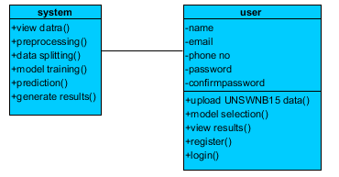
SEQUENCE DIAGRAM
- A sequence diagram in Unified Modeling Language (UML) is a kind of interaction diagram that shows how processes operate with one another and in what order.
- It is a construct of a Message Sequence Chart. Sequence diagrams are sometimes called event diagrams, event scenarios, and timing diagrams.

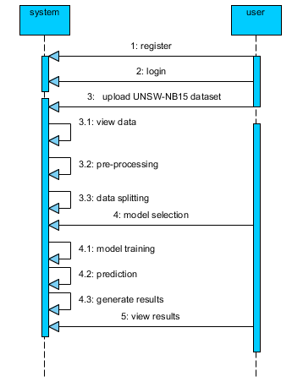

COLLABORATION DIAGRAM:
In collaboration diagram the method call sequence is indicated by some numbering technique as shown below. The number indicates how the methods are called one after another. We have taken the same order management system to describe the collaboration diagram. The method calls are similar to that of a sequence diagram. But the difference is that the sequence diagram does not describe the object organization whereas the collaboration diagram shows the object organization.
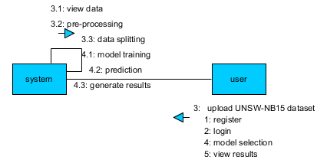

DEPLOYMENT DIAGRAM
Deployment diagram represents the deployment view of a system. It is related to the component diagram. Because the components are deployed using the deployment diagrams. A deployment diagram consists of nodes. Nodes are nothing but physical hardware’s used to deploy the application.
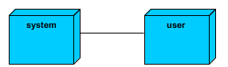

ACTIVITY DIAGRAM:
Activity diagrams are graphical representations of workflows of stepwise activities and actions with support for choice, iteration and concurrency. In the Unified Modeling Language, activity diagrams can be used to describe the business and operational step-by-step workflows of components in a system. An activity diagram shows the overall flow of control.
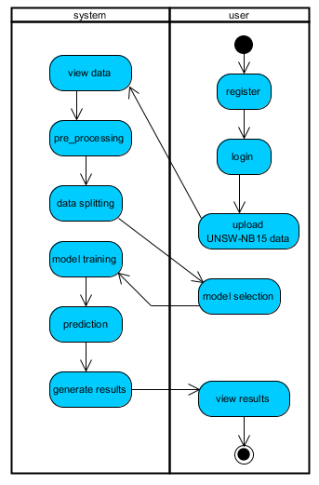

COMPONENT DIAGRAM:
A component diagram, also known as a UML component diagram, describes the organization and wiring of the physical components in a system. Component diagrams are often drawn to help model implementation details and double-check that every aspect of the system's required function is covered by planned development.
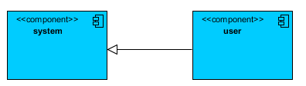

ER DIAGRAM:
An Entity–relationship model (ER model) describes the structure of a database with the help of a diagram, which is known as Entity Relationship Diagram (ER Diagram). An ER model is a design or blueprint of a database that can later be implemented as a database. The main components of E-R model are: entity set and relationship set.
An ER diagram shows the relationship among entity sets. An entity set is a group of similar entities and these entities can have attributes. In terms of DBMS, an entity is a table or attribute of a table in database, so by showing relationship among tables and their attributes, ER diagram shows the complete logical structure of a database. Let’s have a look at a simple ER diagram to understand this concept.

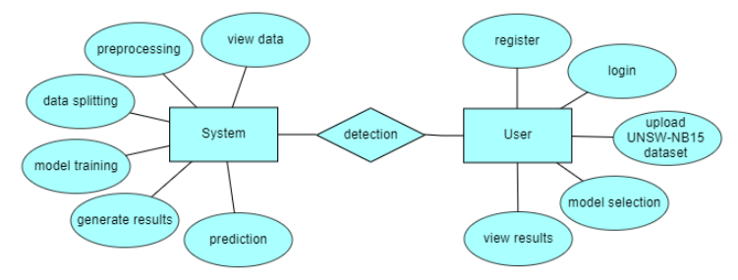
DFD DIAGRAM:
A Data Flow Diagram (DFD) is a traditional way to visualize the information flows within a system. A neat and clear DFD can depict a good amount of the system requirements graphically. It can be manual, automated, or a combination of both. It shows how information enters and leaves the system, what changes the information and where information is stored. The purpose of a DFD is to show the scope and boundaries of a system as a whole. It may be used as a communications tool between a systems analyst and any person who plays a part in the system that acts as the starting point for redesigning a system.
Context level diagram:
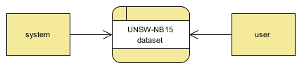
Level 1 diagram:
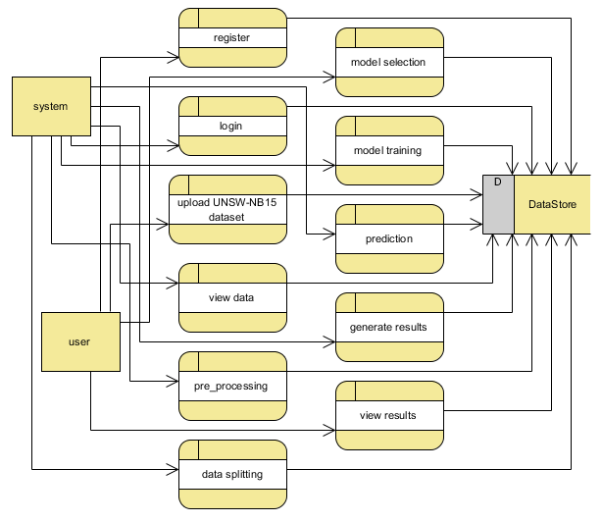

Level 2 diagram:
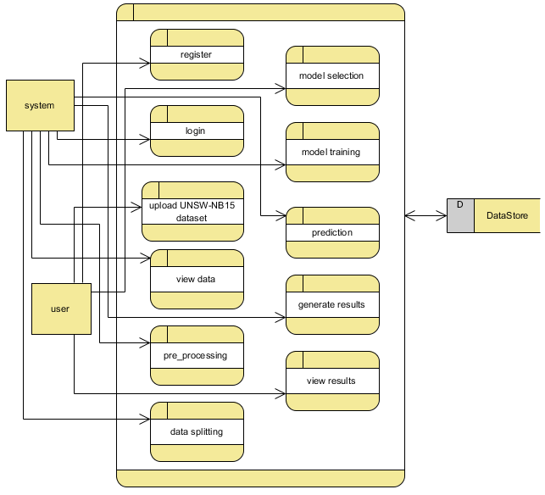

RESULTS AND DISCUSSION

RESULTS

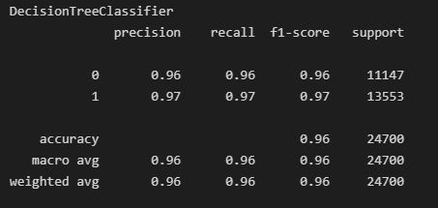

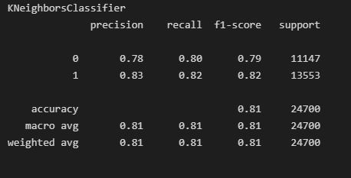

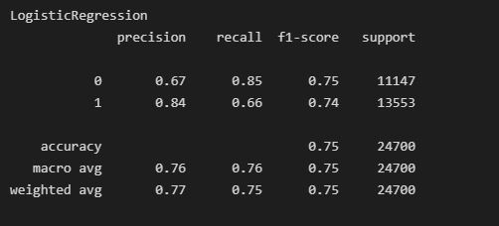
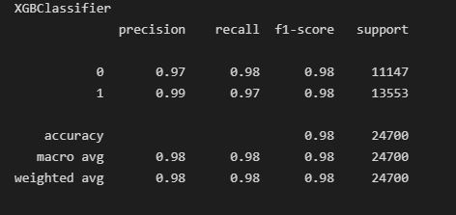

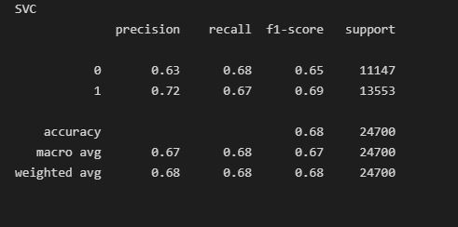

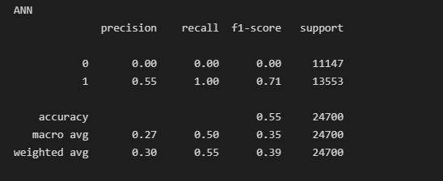
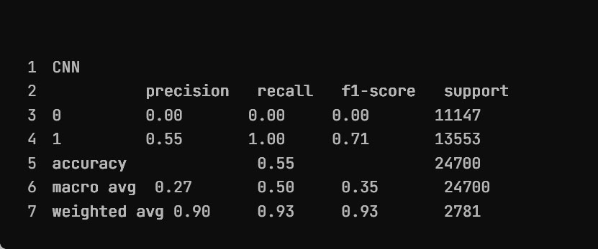

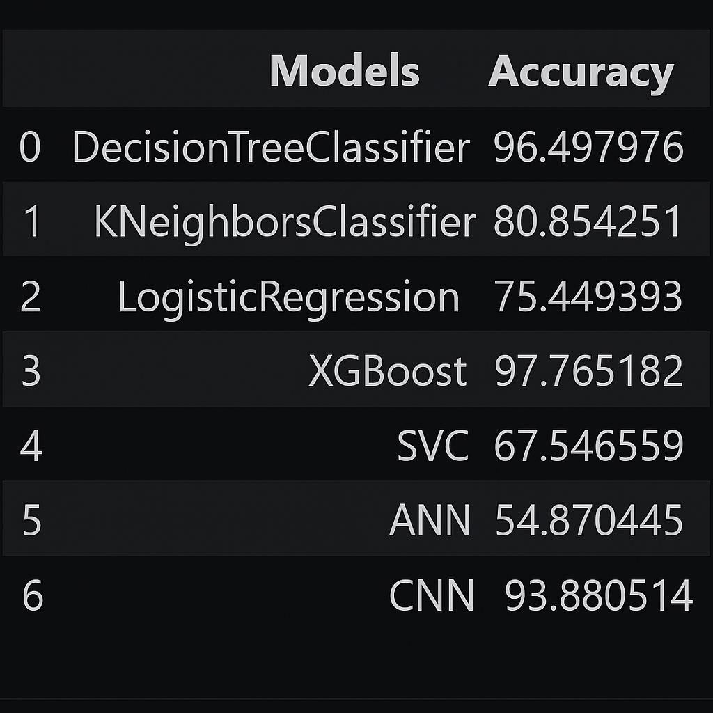

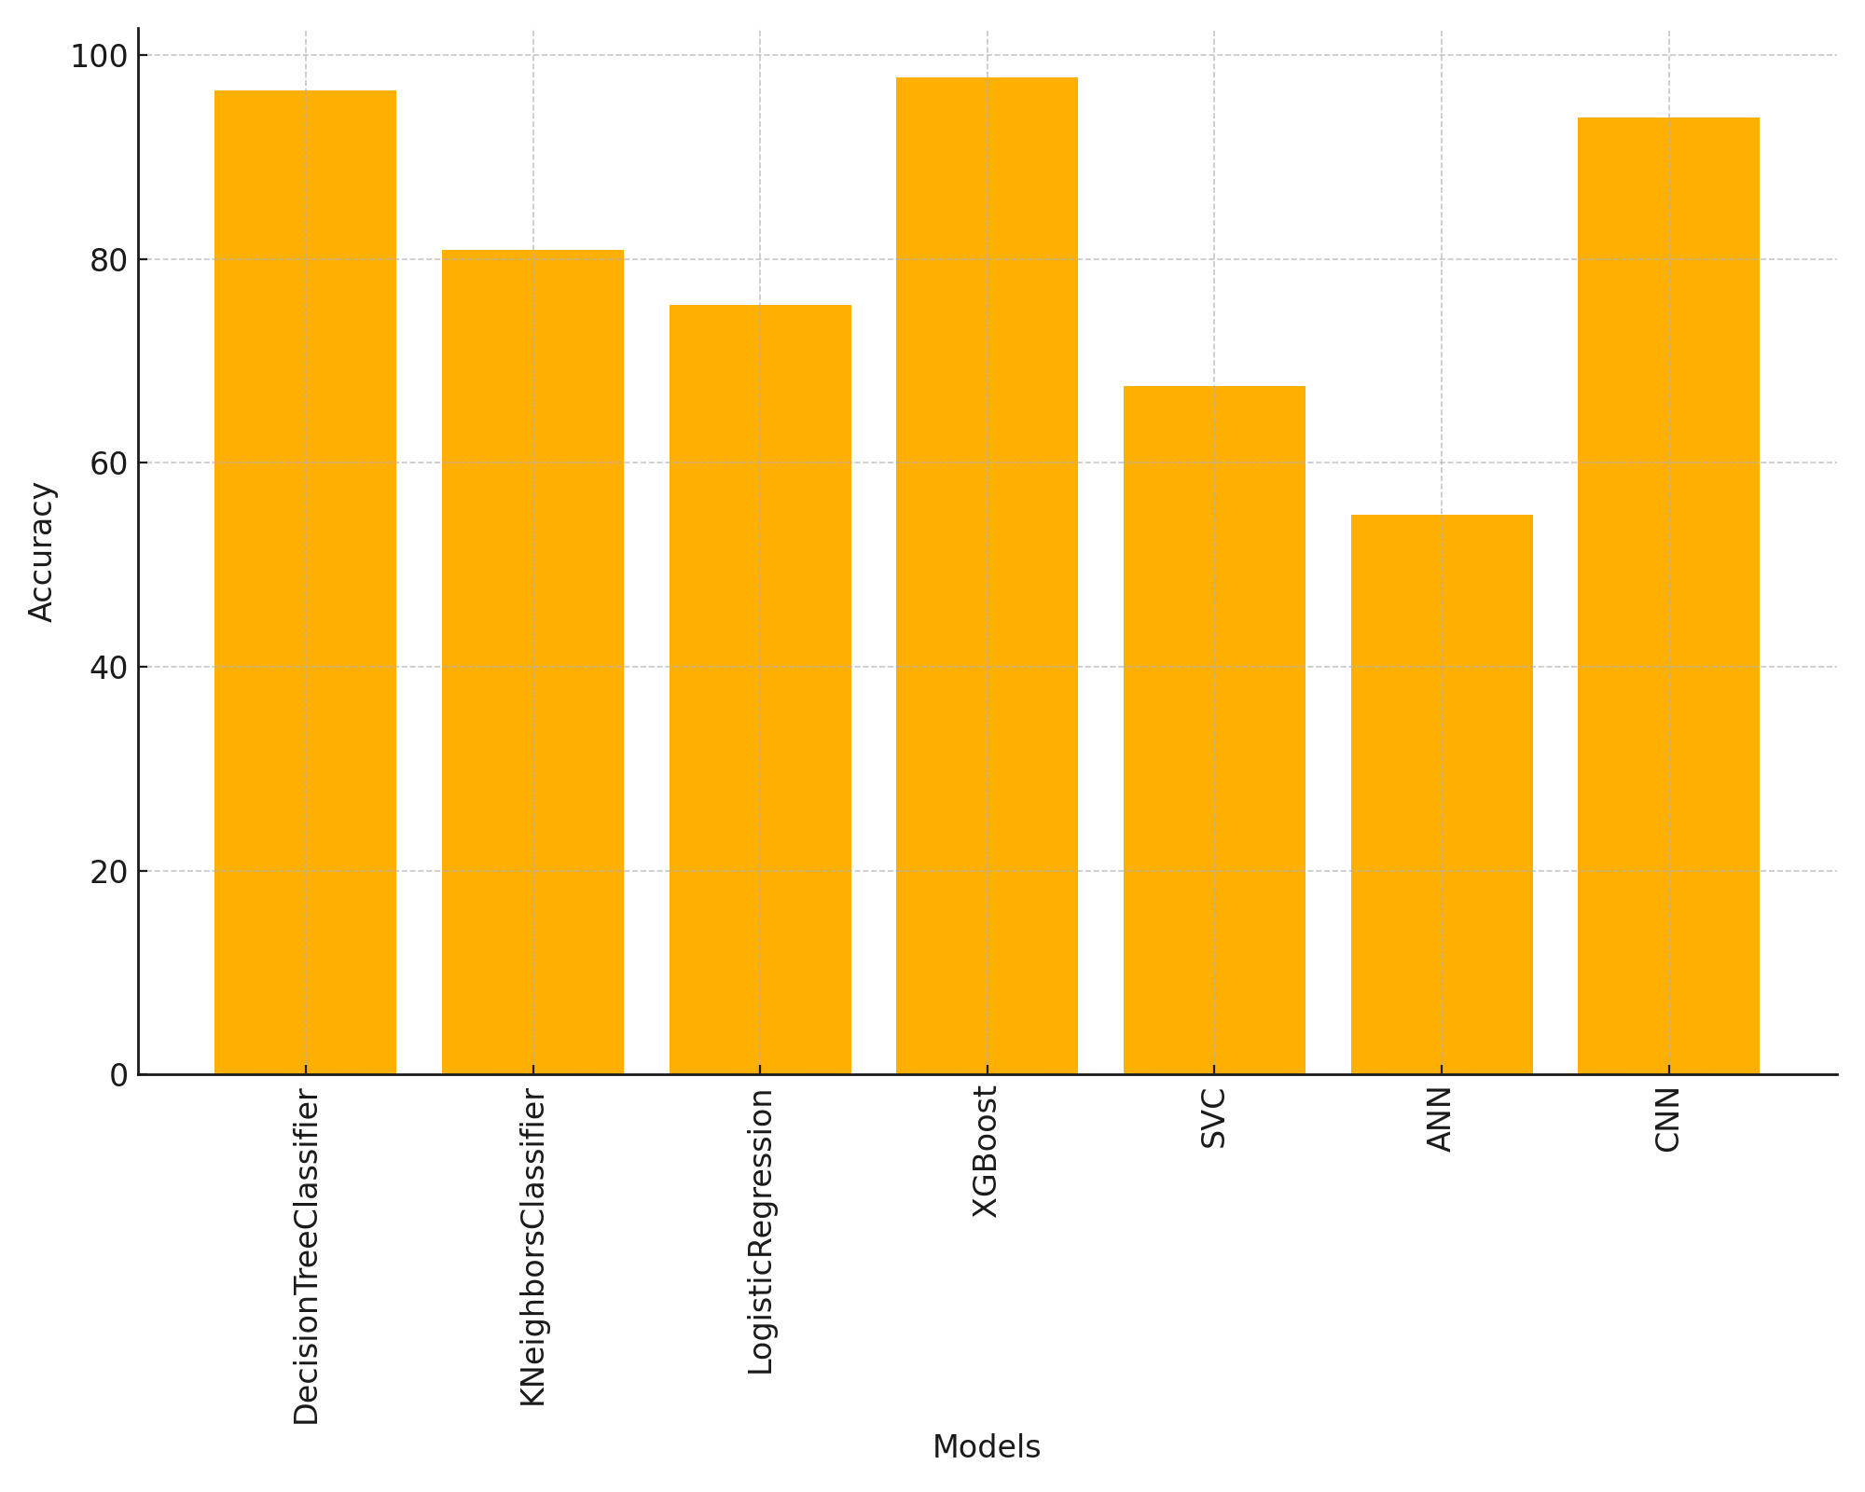

Discussion
In this project, the UNSW-NB15 dataset was used to evaluate the effectiveness of various machine learning and deep learning algorithms for intrusion detection. The models tested include Decision Tree, K-Nearest Neighbors (KNN), Logistic Regression, Support Vector Classifier (SVC), XGBoost, Artificial Neural Network (ANN), and Convolutional Neural Network (CNN). Performance was measured using four key metrics: accuracy, precision, recall, and F1-score. The experiments were conducted using Scikit-learn for traditional machine learning models and TensorFlow for deep learning implementations.
Among all models, XGBoost achieved the highest performance with 98% accuracy, demonstrating its strong ability to handle structured tabular data and capture complex relationships through ensemble learning. The Decision Tree classifier followed closely with 96% accuracy, performing remarkably well despite its simplicity, possibly due to its capability to model decision boundaries effectively in this dataset.
CNN, a deep learning model known for its strong performance in feature extraction, achieved a solid 93% accuracy. Its ability to learn spatial hierarchies and deep representations contributed to its competitive results, though it required more computational resources and longer training time compared to traditional models.
In contrast, models like KNN (81%), Logistic Regression (75%), and SVC (68%) showed moderate to lower performance. KNN's relatively lower accuracy might be attributed to its sensitivity to irrelevant features and the curse of dimensionality, while logistic regression, being a linear model, may not have captured the complex non-linear patterns present in the intrusion data. SVC also underperformed, likely due to its scalability limitations on larger datasets and sensitivity to parameter tuning.
The ANN model performed the lowest with 54% accuracy, suggesting potential issues such as underfitting, lack of sufficient hidden layers, or inadequate training epochs. Unlike CNN, which includes convolutional and pooling layers that enhance its learning capacity, the basic ANN structure might not have been deep or complex enough to extract meaningful patterns from the dataset.

Trade-offs and Observations
While XGBoost emerged as the most accurate model, it also demonstrated efficient training time and scalability, making it a suitable choice for real-time intrusion detection systems. On the other hand, although CNN performed well, its increased training complexity and computational demands may limit its use in resource-constrained environments.
Interestingly, despite being a simple model, Decision Tree performed nearly as well as XGBoost, indicating that the decision boundaries in the dataset might be well-defined and learnable even by non-ensemble methods.
Limitations
Several limitations were encountered during the project:
- ANN's low performance suggests potential underfitting or insufficient model depth, which could be addressed in future iterations.
- Hyperparameter tuning was limited for some models due to time and resource constraints.
- The models were evaluated only on the UNSW-NB15 dataset, and further validation on other datasets would be needed to confirm generalizability.

CONCLUSION
The project successfully developed an Intrusion Detection System (IDS) using machine learning and deep learning models. The key achievements include:
- Implementation of multiple classification models (SVM, kNN, LR, ANN, DT, XGBoost, and CNN).
- Feature selection using XGBoost, which improved model efficiency by reducing the feature space.
- Evaluation of models on the UNSW-NB15 dataset, achieving high accuracy for binary and multiclass classifications.
- Incorporation of CNN for deep learning-based intrusion detection, demonstrating enhanced performance in detecting attack patterns.

FUTURE ENHANCEMENTS
Here are some possible improvements and extensions for this project in the future:
- Better Hyperparameter Tuning
  - Use methods like Grid Search or Random Search to find the best parameters for each model.
- Ensemble Methods
  - Combine multiple models (e.g., XGBoost + Decision Tree) to improve accuracy and reliability.
- Improve ANN Architecture
  - Add more layers or try different activation functions to improve performance.
- Use Other Deep Learning Models
  - Try models like LSTM or a hybrid CNN-LSTM for better feature learning.
- Real-Time Implementation
  - Deploy the best model for real-time intrusion detection using tools like Flask or FastAPI.
- Test on More Datasets
  - Validate the system using other datasets like NSL-KDD or CICIDS2017 to check its general performance.
- Handle Imbalanced Data
  - Use techniques like SMOTE to balance the classes and improve detection of rare attacks.
- Make the Model Explainable
  - Use tools like SHAP or LIME to understand why the model made certain predictions.
- Integrate with Security Tools
  - Connect the system to firewalls or monitoring tools for automated response to threats.

REFERENCES
- Ribeiro J, Saghezchi FB, Mantas G, Rodriguez J, Abd-Alhameed RA. Hidroid: prototyping a behavioral host-based intrusion detection and prevention system for android. IEEE Access. 2020;8:23154–168.
- Van NTT, Thinh TN. Accelerating anomaly-based IDS using neural network on GPU. In: 2015 international conference on advanced computing and applications (ACOMP). IEEE; 2015. pp. 67–74.
- Jabez J, Muthukumar B. Intrusion detection system (IDS): anomaly detection using outlier detection approach. Procedia Comput Sci. 2015;48:338–46.
- Neelakantan S, Rao S. A threat-aware anomaly-based intrusion-detection approach for obtaining network-specifc useful alarms. In: International conference on distributed computing and networking. Springer. 2009; pp. 175–180.
- C. Cortes and V. Vapnik, "Support-Vector Networks", Machine Learning, vol. 20, no. 3, pp. 273-297, 1995.
- J. C. Wiginton, "A note on the comparison of logit and discriminant models of consumer credit behavior", The Journal of Financial and Quantitative Analysis, vol. 15, no. 3, pp. 757, 1980.
- A. K. Reichert, C. Cho and G. M. Wagner, "An examination of the conceptual issues involved in developing credit-scoring models", Journal of Business & Economic Statistics, vol. 1, no. 2, pp. 101, 1983..
- Y. Amit and D. Geman, "Shape quantization and recognition with randomized trees", Neural Computation, vol. 9, no. 7, pp. 1545-1588, 1997.
- T. Harris, "Credit scoring using the clustered support vector machine", Expert Systems with Applications, vol. 42, no. 2, pp. 741-750, 2015.
- C. TSAI and J WU, "Using neural network ensembles for bankruptcy prediction and credit scoring", Expert Systems with Applications, vol. 34, no. 4, pp. 2639-2649, 2008.

APPENDIX
CODE:
A code for libraries used:

import pandas as pd
import numpy as np
from sklearn.model_selection import train_test_split
from sklearn.metrics import accuracy_score,classification_report
from sklearn.svm import SVC
from xgboost import XGBClassifier
import matplotlib.pyplot as plt
import seaborn as sns
from sklearn.preprocessing import LabelEncoder
from sklearn.tree import DecisionTreeClassifier
from sklearn.neighbors import KNeighborsClassifier
from sklearn.linear_model import LogisticRegression
import tensorflow as tf
from tensorflow.keras.preprocessing.image import ImageDataGenerator
from tensorflow.keras.models import Sequential
from tensorflow.keras.layers import Conv2D, MaxPooling2D, Flatten, Dense, Dropout
from tensorflow.keras.optimizers import Adam
from tensorflow.keras.callbacks import EarlyStopping

Code for Decision Tree Classifier :
dt = DecisionTreeClassifier()
dt.fit(x_train,y_train)
pred = dt.predict(x_test)
acc = accuracy_score(y_test,pred)
acc
cls = classification_report(y_test,pred)
print('DecisionTreeClassifier')
print(cls)

Code for KNeighborsClassifier :
knn = KNeighborsClassifier()
knn.fit(x_train,y_train)
pred1 = knn.predict(x_test)
acc1 = accuracy_score(y_test,pred1)
acc1
cls1 = classification_report(y_test,pred1)
print('KNeighborsClassifier')
print(cls1)
Code for LogisticRegression:
lr = LogisticRegression()
lr.fit(x_train,y_train)
pred2 = lr.predict(x_test)
acc2 = accuracy_score(y_test,pred2)
acc2
cls2 = classification_report(y_test,pred2)
print('LogisticRegression')
print(cls2)
Code for XGBClassifier:
xg = XGBClassifier()
xg.fit(x_train,y_train)
pred3 = xg.predict(x_test)
acc3 = accuracy_score(y_test,pred3)
acc3
cls3 = classification_report(y_test,pred3)
print('XGBClassifier')
print(cls3)
Code for SVC:
sv = SVC()
sv.fit(x_train[:1000],y_train[:1000])
pred4 = sv.predict(x_test)
acc4 = accuracy_score(y_test,pred4)
acc4
cls4 = classification_report(y_test,pred4)
print('SVC')
print(cls4)
Importing and Code for ANN :
from tensorflow.keras.models import Sequential
from tensorflow.keras.layers import Dense
import tensorflow as tf
model = Sequential()
model.add(Dense(30, activation='relu'))
model.add(Dense(20, activation='relu'))
model.add(Dense(1, activation='softmax'))
model.compile(optimizer='adam', loss='binary_crossentropy', metrics=['accuracy'])
model.fit(x_train, y_train, batch_size=500, epochs=10,validation_data=(x_test, y_test))
Importing and Code for CNN :
from tensorflow.keras.models import Sequential
from tensorflow.keras.layers import Conv2D, MaxPooling2D, Flatten, Dense, Dropout
from tensorflow.keras.optimizers import Adam
model = Sequential()
model.add(Conv2D(32, (3, 3), activation='relu', padding='same', input_shape=(201, 1, 1)))
model.add(MaxPooling2D(pool_size=(2, 1)))
model.add(Conv2D(64, (3, 3), activation='relu', padding='same'))
model.add(MaxPooling2D(pool_size=(2, 1))) # Reduced pooling
model.add(Flatten())
model.add(Dense(128, activation='relu'))
model.add(Dropout(0.5)) # Dropout for regularization
model.add(Dense(len(y.unique()), activation='softmax'
model.compile(optimizer=Adam(learning_rate=0.001),
loss='sparse_categorical_crossentropy',
metrics=['accuracy'])
model.summary()

OUTPUT SCREEN SHOTS WITH DESCRIPTION.

Home Page:
Here user view the home page of Performance Analysis of Intrusion Detection Systems Using a Feature Selection Method web appellation.


Fig2: Home Page

About:
In the about page, users can learn more about Performance Analysis of Intrusion Detection Systems Using a Feature Selection Method.
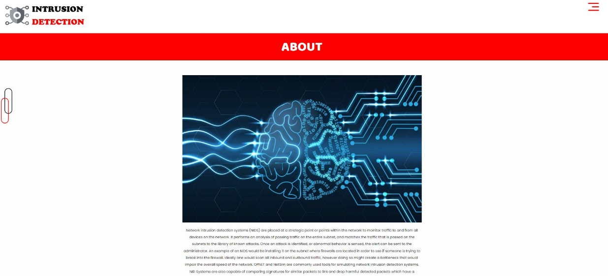
Fig3: About

Login:
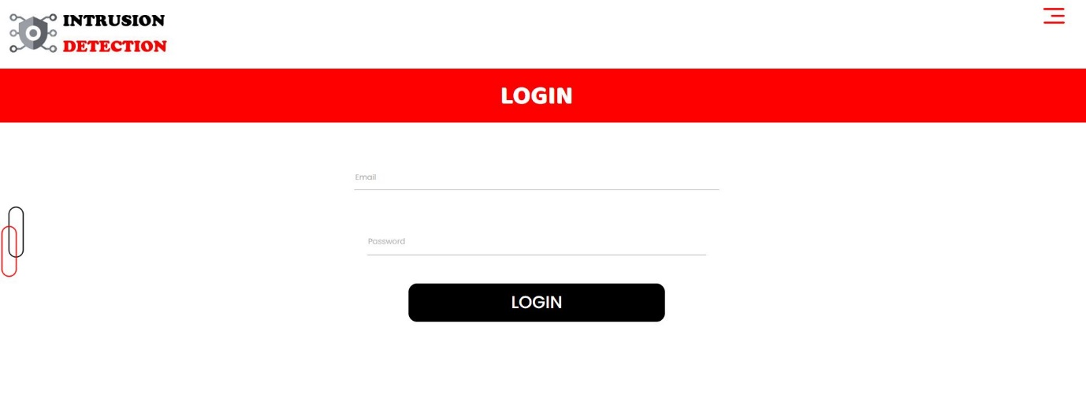
Fig4: Login.

Registration:
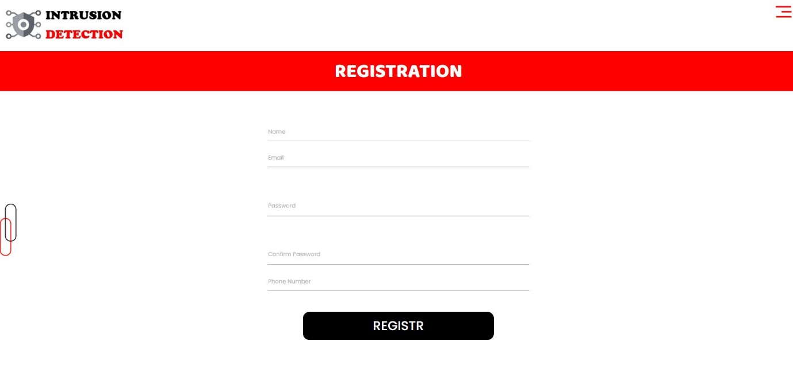
Fig5: Registration.

User Home Page:


Fig6: User Home page.

Upload Data Set:
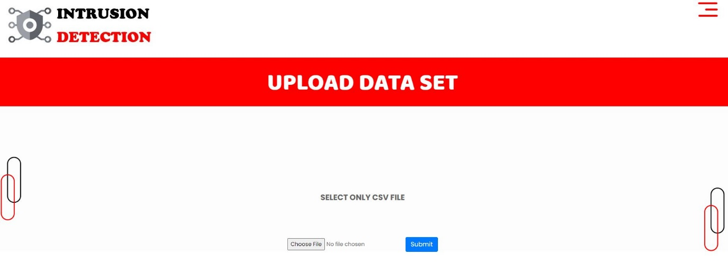

Fig7: Upload dataset.

View:
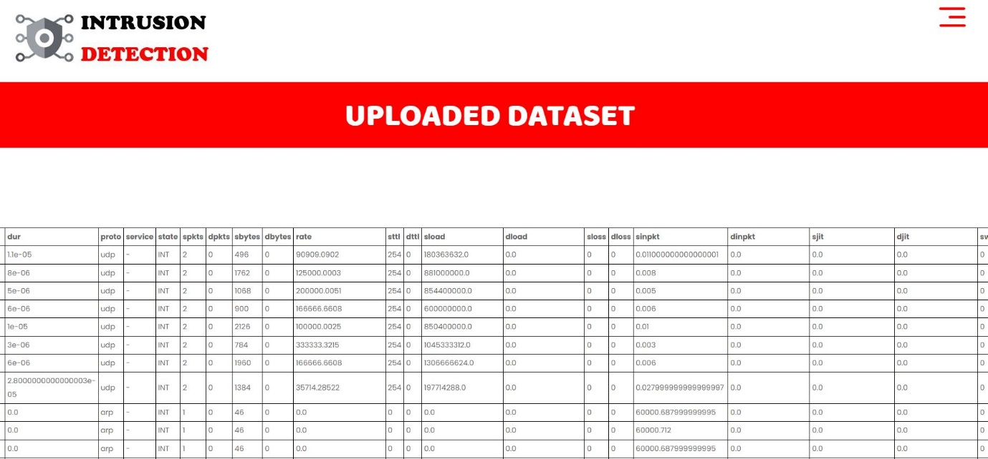

Fig8: View.

Preprocessing:
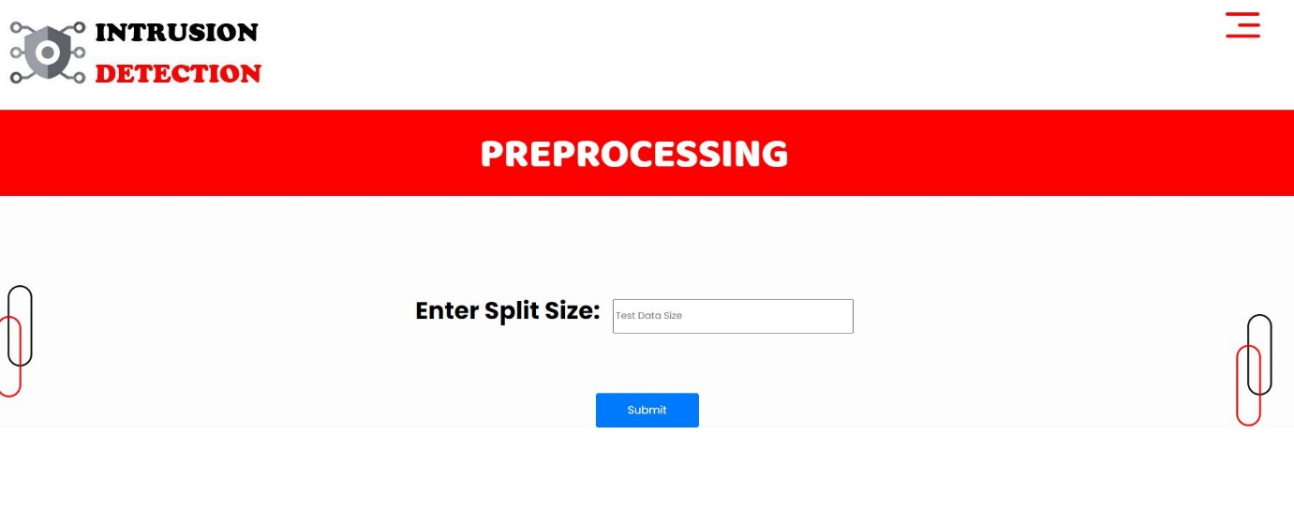

Fig9: Preprocessing

Training:
We’re training the algorithm to see which one has the best accuracy.
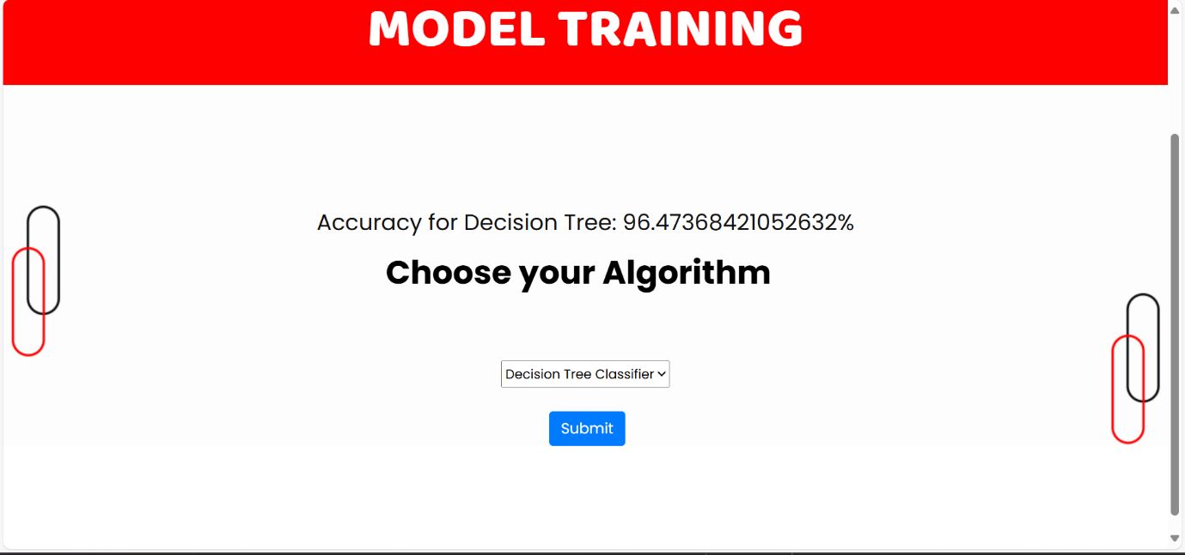
Fig10: Training Algorithm
Prediction:
This page show Performance Analysis of Intrusion Detection Systems Using a Feature Selection Method will predict Normal are attack.
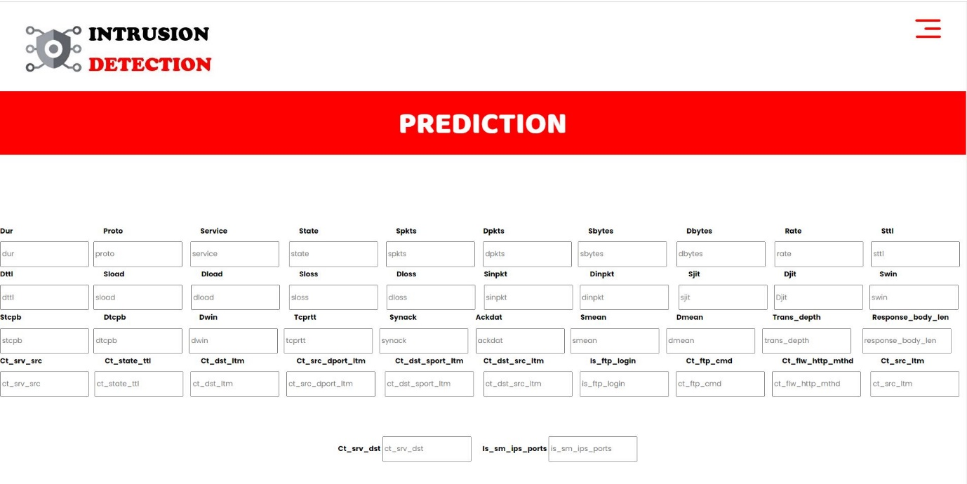

Fig11: Prediction

Graph:

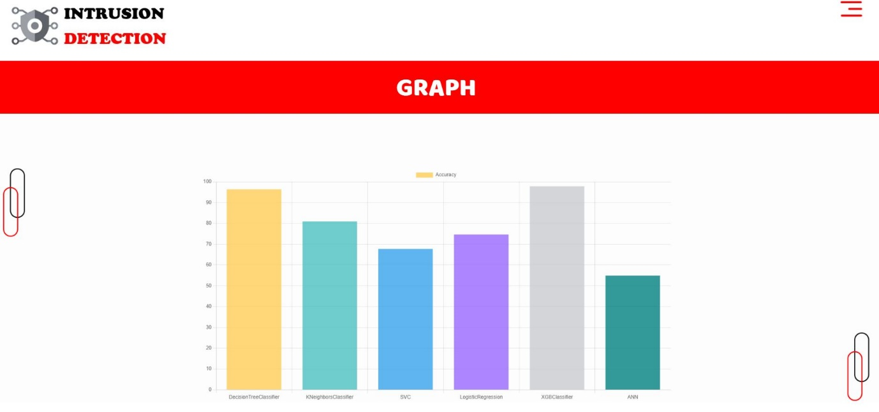

Fig12: Graph
TEST CASES:
Input | Output | Result
Input | Tested for different model given by user on the different model. | Success
Decision Tree | Tested for different input given by the user on different models are created using the different algorithms and data. | Success
Prediction | Prediction will be performed using the different models build from the algorithms. | Success

Test cases Model building:
S.NO | Test cases | I/O | Expected O/T | Actual O/T | P/F
1 | Read the datasets. | Dataset’s path. | Datasets need to read successfully. | Datasets fetched successfully. | It produced P. If this not F will come
2 | Verifying the Performance Analysis of Intrusion Detection Systems Using a Feature Selection Method identify type of Normal are attack. | Input for Performance Analysis of Intrusion Detection Systems Using a Feature Selection Method  classification | Output as either in the form Normal are attack. | Output is classified as Normal are attack. | It produced P. If this is not, it will undergo F
3 | Verifying the  Performance Analysis of Intrusion Detection Systems Using a Feature Selection Method identify type of Normal are attack. | Input for Performance Analysis of Intrusion Detection Systems Using a Feature Selection Method classification | Output as either in the form Normal are attack. | Output is classified Normal are attack. | It produced P. If this is not, it will undergo F
4 | Verifying the Performance Analysis of Intrusion Detection Systems Using a Feature Selection Method identify type of Normal are attack. | Input Performance Analysis of Intrusiprediction the result | Need to predict the best accuracy | Model successfully predicted best accuracy | It produced P. If this is not, it will undergo F

BIBLIOGRAPHY:
SOFTWARE INSTALLATION FOR MACHINE LEARNING PROJECTS:
Installing Python:
- To download and install Python visit the official website of Python https://www.python.org/downloads/ and choose your version.
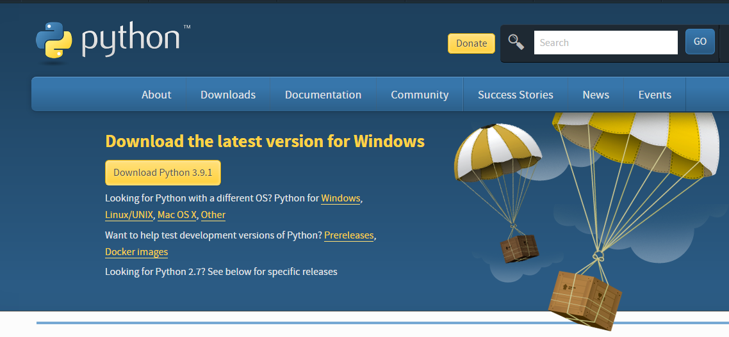
- Once the download is complete, run the exe for install Python. Now click on Install Now.
- You can see Python installing at this point.
- When it finishes, you can see a screen that says the Setup was successful. Now click on "Close".
Installing PyCharm:
- To download PyCharm visit the website https://www.jetbrains.com/pycharm/download/ and click the "DOWNLOAD" link under the Community Section.

- Once the download is complete, run the exe for install PyCharm. The setup wizard should have started. Click “Next”.
- On the next screen, Change the installation path if required. Click “Next”.
- On the next screen, you can create a desktop shortcut if you want and click on “Next”.
- Choose the start menu folder. Keep selected Jet Brains and click on “Install”.
- Wait for the installation to finish.
- Once installation finished, you should receive a message screen that PyCharm is installed. If you want to go ahead and run it, click the “Run PyCharm Community Edition” box first and click “Finish”.
- After you click on "Finish," the Following screen will appear.
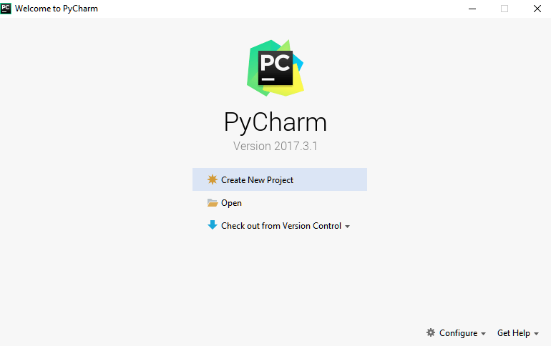
9. You need to install some packages to execute your project in a proper way.
10. Open the command prompt/ anaconda prompt or terminal as administrator.
11. The prompt will get open, with specified path, type “pip install package name” which you want to install (like NumPy, pandas, sea born, scikit-learn, Matplotlib, Pyplot)
Ex: Pip install NumPy
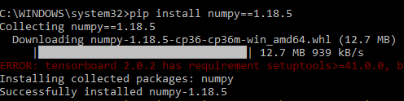

INTRODUCTION TO PYTHON
- Python

What Is a Script?
Up to this point, I have concentrated on the interactive programming capability of Python. This is a very useful capability that allows you to type in a program and to have it executed immediately in an interactive mode
Scripts are reusable
Basically, a script is a text file containing the statements that comprise a Python program. Once you have created the script, you can execute it over and over without having to retype it each time.
Scripts are editable
Perhaps, more importantly, you can make different versions of the script by modifying the statements from one file to the next using a text editor. Then you can execute each of the individual versions. In this way, it is easy to create different programs with a minimum amount of typing.
You will need a text editor
Just about any text editor will suffice for creating Python script files.
You can use Microsoft Notepad, Microsoft WordPad, Microsoft Word, or just about any word processor if you want to.
Difference between a script and a program
Script:
Scripts are distinct from the core code of the application, which is usually written in a different language, and are often created or at least modified by the end-user. Scripts are often interpreted from source code or byte code, whereas the applications they control are traditionally compiled to native machine code.
Program:
The program has an executable form that the computer can use directly to execute the instructions.
The same program in its human-readable source code form, from which executable programs are derived (e.g., compiled)
Python
What is Python? Chances you are asking yourself this. You may have found this book because you want to learn to program but don’t know anything about programming languages. Or you may have heard of programming languages like C, C++, C#, or Java and want to know what Python is and how it compares to “big name” languages. Hopefully I can explain it for you.
Python concepts
If you’re not interested in the how’s and whys of Python, feel free to skip to the next chapter. In this chapter I will try to explain to the reader why I think Python is one of the best languages available and why it’s a great one to start programming with.
• Open-source general-purpose language.
• Object Oriented, Procedural, Functional
• Easy to interface with C/ObjC/Java/Fortran
• Easy-is to interface with C++ (via SWIG)
• Great interactive environment
• Great interactive environment
Python is a high-level, interpreted, interactive and object-oriented scripting language. Python is designed to be highly readable. It uses English keywords frequently where as other languages use punctuation, and it has fewer syntactical constructions than other languages.
- Python is Interpreted − Python is processed at runtime by the interpreter. You do not need to compile your program before executing it. This is similar to PERL and PHP.
- Python is Interactive − you can actually sit at a Python prompt and interact with the interpreter directly to write your programs.
- Python is Object-Oriented − Python supports Object-Oriented style or technique of programming that encapsulates code within objects.
- Python is a Beginner's Language − Python is a great language for the beginner-level programmers and supports the development of a wide range of applications from simple text processing to WWW browsers to games.

History of Python
Python was developed by Guido van Possum in the late eighties and early nineties at the National Research Institute for Mathematics and Computer Science in the Netherlands.
Python is derived from many other languages, including ABC, Modula-3, C, C++, Algol-68, Smalltalk, and UNIX shell and other scripting languages.
Python is copyrighted. Like Perl, Python source code is now available under the GNU General Public License (GPL).
Python is now maintained by a core development team at the institute, although Guido van Possum still holds a vital role in directing its progress.

Python Features
Python's features include −
- Easy-to-learn − Python has few keywords, simple structure, and a clearly defined syntax. This allows the student to pick up the language quickly.
- Easy-to-read − Python code is more clearly defined and visible to the eyes.
- Easy-to-maintain − Python's source code is fairly easy-to-maintained.
- A broad standard library − Python's bulk of the library is very portable and cross-platform compatible on UNIX, Windows, and Macintosh.
- Interactive Mode − Python has support for an interactive mode which allows interactive testing and debugging of snippets of code.
- Portable − Python can run on a wide variety of hardware platforms and has the same interface on all platforms.
- Extendable − you can add low-level modules to the Python interpreter. These modules enable programmers to add to or customize their tools to be more efficient.
- Databases − Python provides interfaces to all major commercial databases.
- GUI Programming − Python supports GUI applications that can be created and ported to many system calls, libraries and windows systems, such as Windows MFC, Macintosh, and the X Window system of Unix.
- Scalable − Python provides a better structure and support for large programs than shell scripting.

Apart from the above-mentioned features, Python has a big list of good features, few are listed below −
- It supports functional and structured programming methods as well as OOP.
- It can be used as a scripting language or can be compiled to byte-code for building large applications.
- It provides very high-level dynamic data types and supports dynamic type checking.
- IT supports automatic garbage collection.
- It can be easily integrated with C, C++, COM, ActiveX, CORBA, and Java.

Dynamic vs. Static
Types Python is a dynamic-typed language. Many other languages are static typed, such as C/C++ and Java. A static typed language requires the programmer to explicitly tell the computer what type of “thing” each data value is.
For example, in C if you had a variable that was to contain the price of something, you would have to declare the variable as a “float” type.
This tells the compiler that the only data that can be used for that variable must be a floating point number, i.e. a number with a decimal point.
If any other data value was assigned to that variable, the compiler would give an error when trying to compile the program.
Python, however, doesn’t require this. You simply give your variables names and assign values to them. The interpreter takes care of keeping track of what kinds of objects your program is using. This also means that you can change the size of the values as you develop the program. Say you have another decimal number (a.k.a. a floating point number) you need in your program.
With a static typed language, you have to decide the memory size the variable can take when you first initialize that variable. A double is a floating point value that can handle a much larger number than a normal float (the actual memory sizes depend on the operating environment).
If you declare a variable to be a float but later on assign a value that is too big to it, your program will fail; you will have to go back and change that variable to be a double.
With Python, it doesn’t matter. You simply give it whatever number you want and Python will take care of manipulating it as needed. It even works for derived values.
For example, say you are dividing two numbers. One is a floating point number and one is an integer. Python realizes that it’s more accurate to keep track of decimals so it automatically calculates the result as a floating point number
Variables
Variables are nothing but reserved memory locations to store values. This means that when you create a variable you reserve some space in memory.
Based on the data type of a variable, the interpreter allocates memory and decides what can be stored in the reserved memory. Therefore, by assigning different data types to variables, you can store integers, decimals or characters in these variables.

Standard Data Types
The data stored in memory can be of many types. For example, a person's age is stored as a numeric value and his or her address is stored as alphanumeric characters. Python has various standard data types that are used to define the operations possible on them and the storage method for each of them.
Python has five standard data types −
- Numbers
- String
- List
- Tuple
- Dictionary

Python Numbers
Number data types store numeric values. Number objects are created when you assign a value to them.

Python Strings
Strings in Python are identified as a contiguous set of characters represented in the quotation marks. Python allows for either pairs of single or double quotes. Subsets of strings can be taken using the slice operator ([ ] and [:]) with indexes starting at 0 in the beginning of the string and working their way from -1 at the end.

Python Lists
Lists are the most versatile of Python's compound data types. A list contains items separated by commas and enclosed within square brackets ([]). To some extent, lists are similar to arrays in C. One difference between them is that all the items belonging to a list can be of different data type.
The values stored in a list can be accessed using the slice operator ([ ] and [:]) with indexes starting at 0 in the beginning of the list and working their way to end -1. The plus (+) sign is the list concatenation operator, and the asterisk (*) is the repetition operator.

Python Tuples
A tuple is another sequence data type that is similar to the list. A tuple consists of a number of values separated by commas. Unlike lists, however, tuples are enclosed within parentheses.
The main differences between lists and tuples are: Lists are enclosed in brackets ([ ]) and their elements and size can be changed, while tuples are enclosed in parentheses (( )) and cannot be updated. Tuples can be thought of as read-only lists.

Python Dictionary
Python's dictionaries are kind of hash table type. They work like associative arrays or hashes found in Perl and consist of key-value pairs. A dictionary key can be almost any Python type, but are usually numbers or strings. Values, on the other hand, can be any arbitrary Python object.
Dictionaries are enclosed by curly braces ({ }) and values can be assigned and accessed using square braces ([]).

Different modes in python
Python has two basic modes: normal and interactive.
The normal mode is the mode where the scripted and finished .pie files are run in the Python interpreter.
Interactive mode is a command line shell which gives immediate feedback for each statement, while running previously fed statements in active memory. As new lines are fed into the interpreter, the fed program is evaluated both in part and in whole

20 Python libraries
1. Requests. The most famous http library written by Kenneth remits. It’s a must have for every python developer.
2. Scrappy. If you are involved in web scraping then this is a must have library for you. After using this library you won’t use any other.
3. Python. A guy toolkit for python. I have primarily used it in place of tinder. You will really love it.
4. Pillow. A friendly fork of PIL (Python Imaging Library). It is more user friendly than PIL and is a must have for anyone who works with images.
5. SQL Alchemy. A database library. Many love it and many hate it. The choice is yours.
6. Beautiful Soup. I know it’s slow but this xml and html parsing library is very useful for beginners.
7. Twisted. The most important tool for any network application developer. It has a very beautiful ape and is used by a lot of famous python developers.
8. Numbly. How can we leave this very important library? It provides some advance math functionalities to python.
9. Skippy. When we talk about numbly then we have to talk about spicy. It is a library of algorithms and mathematical tools for python and has caused many scientists to switch from ruby to python.
10. Matplotlib. A numerical plotting library. It is very useful for any data scientist or any data analyzer.
11. Pygmy. Which developer does not like to play games and develop them? This library will help you achieve your goal of 2d game development.
12. Piglet. A 3d animation and game creation engine. This is the engine in which the famous python port of mine craft was made
13. Pit. A GUI toolkit for python. It is my second choice after python for developing GUI’s for my python scripts.
14. Pit. Another python GUI library. It is the same library in which the famous Bit torrent client is created.
15. Scaly. A packet sniffer and analyzer for python made in python.
16. Pywin32. A python library which provides some useful methods and classes for interacting with windows.
17. Notch. Natural Language Toolkit – I realize most people won’t be using this one, but it’s generic enough. It is a very useful library if you want to manipulate strings. But its capacity is beyond that. Do check it out.
18. Nose. A testing framework for python. It is used by millions of python developers. It is a must have if you do test driven development.
19. Simply. Simply can do algebraic evaluation, differentiation, expansion, complex numbers, etc. It is contained in a pure Python distribution.
20. I Python. I just can’t stress enough how useful this tool is. It is a python prompt on steroids. It has completion, history, shell capabilities, and a lot more. Make sure that you take a look at it.

Numpy
Humpy’s main object is the homogeneous multidimensional array. It is a table of elements (usually numbers), all of the same type, indexed by a tuple of positive integers. In numbly dimensions are called axes. The number of axes is rank.
• Offers Matlab-ish capabilities within Python
• Fast array operations
• 2D arrays, multi-D arrays, linear algebra etc.
Matplotlib
• High quality plotting library.
Python class and objects
These are the building blocks of OOP. Class creates a new object. This object can be anything, whether an abstract data concept or a model of a physical object, e.g. a chair. Each class has individual characteristics unique to that class, including variables and methods. Classes are very powerful and currently “the big thing” in most programming languages. Hence, there are several chapters dedicated to OOP later in the book.
The class is the most basic component of object-oriented programming. Previously, you learned how to use functions to make your program do something.
Now will move into the big, scary world of Object-Oriented Programming (OOP). To be honest, it took me several months to get a handle on objects.
When I first learned C and C++, I did great; functions just made sense for me.
Having messed around with BASIC in the early ’90s, I realized functions were just like subroutines so there wasn’t much new to learn.
However, when my C++ course started talking about objects, classes, and all the new features of OOP, my grades definitely suffered.
Once you learn OOP, you’ll realize that it’s actually a pretty powerful tool. Plus many Python libraries and APIs use classes, so you should at least be able to understand what the code is doing.
One thing to note about Python and OOP: it’s not mandatory to use objects in your code in a way that works best; maybe you don’t need to have a full-blown class with initialization code and methods to just return a calculation. With Python, you can get as technical as you want.
As you’ve already seen, Python can do just fine with functions. Unlike languages such as Java, you aren’t tied down to a single way of doing things; you can mix functions and classes as necessary in the same program. This lets you build the code
Objects are an encapsulation of variables and functions into a single entity. Objects get their variables and functions from classes. Classes are essentially a template to create your objects.
Here’s a brief list of Python OOP ideas:
• The class statement creates a class object and gives it a name. This creates a new namespace.
• Assignments within the class create class attributes. These attributes are accessed by qualifying the name using dot syntax: ClassName.Attribute.
• Class attributes export the state of an object and its associated behavior. These attributes are shared by all instances of a class.
• Calling a class (just like a function) creates a new instance of the class.
This is where the multiple copies part comes in.
• Each instance gets ("inherits") the default class attributes and gets its own namespace. This prevents instance objects from overlapping and confusing the program.
• Using the term self identifies a particular instance, allowing for per-instance attributes. This allows items such as variables to be associated with a particular instance.
Inheritance
First off, classes allow you to modify a program without really making changes to it.
To elaborate, by sub classing a class, you can change the behaviour of the program by simply adding new components to it rather than rewriting the existing components.
As we’ve seen, an instance of a class inherits the attributes of that class.
However, classes can also inherit attributes from other classes. Hence, a subclass inherits from a superclass allowing you to make a generic superclass that is specialized via subclasses.
The subclasses can override the logic in a superclass, allowing you to change the behavior of your classes without changing the superclass at all.
Operator Overloads
Operator overloading simply means that objects that you create from classes can respond to actions (operations) that are already defined within Python, such as addition, slicing, printing, etc.
Even though these actions can be implemented via class methods, using overloading ties the behavior closer to Python’s object model and the object interfaces are more consistent to Python’s built-in objects, hence overloading is easier to learn and use.
User-made classes can override nearly all of Python’s built-in operation methods
Exceptions
I’ve talked about exceptions before but now I will talk about them in depth. Essentially, exceptions are events that modify program’s flow, either intentionally or due to errors.
They are special events that can occur due to an error, e.g. trying to open a file that doesn’t exist, or when the program reaches a marker, such as the completion of a loop.
Exceptions, by definition, don’t occur very often; hence, they are the "exception to the rule" and a special class has been created for them. Exceptions are everywhere in Python.
Virtually every module in the standard Python library uses them, and Python itself will raise them in a lot of different circumstances.
Here are just a few examples:
• Accessing a non−existent dictionary key will raise a Key Error exception.
• Searching a list for a non−existent value will raise a Value Error exception
. • Calling a non−existent method will raise an Attribute Error exception.
• Referencing a non−existent variable will raise a Name Error exception.
• Mixing data types without coercion will raise a Type Error exception.
One use of exceptions is to catch a fault and allow the program to continue working; we have seen this before when we talked about files.
This is the most common way to use exceptions. When programming with the Python command line interpreter, you don’t need to worry about catching exceptions.
Your program is usually short enough to not be hurt too much if an exception occurs.
Plus, having the exception occur at the command line is a quick and easy way to tell if your code logic has a problem.
However, if the same error occurred in your real program, it will fail and stop working. Exceptions can be created manually in the code by raising an exception.
It operates exactly as a system-caused exceptions, except that the programmer is doing it on purpose. This can be for a number of reasons. One of the benefits of using exceptions is that, by their nature, they don’t put any overhead on the code processing.
Because exceptions aren’t supposed to happen very often, they aren’t processed until they occur.
Exceptions can be thought of as a special form of the if/elf statements. You can realistically do the same thing with if blocks as you can with exceptions.
However, as already mentioned, exceptions aren’t processed until they occur; if blocks are processed all the time.
Proper use of exceptions can help the performance of your program.
The more infrequent the error might occur, the better off you are to use exceptions; using if blocks requires Python to always test extra conditions before continuing.
Exceptions also make code management easier: if your programming logic is mixed in with error-handling if statements, it can be difficult to read, modify, and debug your program.
User-Defined Exceptions
I won’t spend too much time talking about this, but Python does allow for a programmer to create his own exceptions.
You probably won’t have to do this very often but it’s nice to have the option when necessary.
However, before making your own exceptions, make sure there isn’t one of the built-in exceptions that will work for you.
They have been "tested by fire" over the years and not only work effectively, they have been optimized for performance and are bug-free.
Making your own exceptions involves object-oriented programming, which will be covered in the next chapter
To make a custom exception, the programmer determines which base exception to use as the class to inherit from, e.g. making an exception for negative numbers or one for imaginary numbers would probably fall under the Arithmetic Error exception class.
To make a custom exception, simply inherit the base exception and define what it will do.
Python modules
Python allows us to store our code in files (also called modules). This is very useful for more serious programming, where we do not want to retype a long function definition from the very beginning just to change one mistake. In doing this, we are essentially defining our own modules, just like the modules defined already in the Python library.
To support this, Python has a way to put definitions in a file and use them in a script or in an interactive instance of the interpreter. Such a file is called a module; definitions from a module can be imported into other modules or into the main module.
Testing code
As indicated above, code is usually developed in a file using an editor.
To test the code, import it into a Python session and try to run it.
Usually there is an error, so you go back to the file, make a correction, and test again.
This process is repeated until you are satisfied that the code works. T
His entire process is known as the development cycle.
There are two types of errors that you will encounter. Syntax errors occur when the form of some command is invalid.
This happens when you make typing errors such as misspellings, or call something by the wrong name, and for many other reasons. Python will always give an error message for a syntax error.
Functions in Python
It is possible, and very useful, to define our own functions in Python. Generally speaking, if you need to do a calculation only once, then use the interpreter. But when you or others have need to perform a certain type of calculation many times, then define a function.
You use functions in programming to bundle a set of instructions that you want to use repeatedly or that, because of their complexity, are better self-contained in a sub-program and called when needed. That means that a function is a piece of code written to carry out a specified task.

To carry out that specific task, the function might or might not need multiple inputs. When the task is carved out, the function can or cannot return one or more values.

There are three types of functions in python:

Help (), min (), print ().
Namespaces in Python are implemented as Python dictionaries, this means it is a mapping from names (keys) to objects (values). The user doesn't have to know this to write a Python program and when using namespaces.
Some namespaces in Python:
- global names of a module
- local names in a function or method invocation
- built-in names: this namespace contains built-in functions (e.g. abs(), camp(), ...) and built-in exception names
Garbage Collection
Garbage Collector exposes the underlying memory management mechanism of Python, the automatic garbage collector. The module includes functions for controlling how the collector operates and to examine the objects known to the system, either pending collection or stuck in reference cycles and unable to be freed.
Python XML Parser
XML is a portable, open source language that allows programmers to develop applications that can be read by other applications, regardless of operating system and/or developmental language.
What is XML? The Extensible Markup Language XML is a markup language much like HTML or SGML.
This is recommended by the World Wide Web Consortium and available as an open standard.
XML is extremely useful for keeping track of small to medium amounts of data without requiring a SQL-based backbone.
XML Parser Architectures and APIs the Python standard library provides a minimal but useful set of interfaces to work with XML.
The two most basic and broadly used APIs to XML data are the SAX and DOM interfaces.
Simple API for XML SAX: Here, you register call-backs for events of interest and then let the parser proceed through the document.
This is useful when your documents are large or you have memory limitations, it parses the file as it reads it from disk and the entire file is never stored in memory.
Document Object Model DOM API : This is a World Wide Web Consortium recommendation wherein the entire file is read into memory and stored in a hierarchical tree − based form to represent all the features of an XML document.
SAX obviously cannot process information as fast as DOM can when working with large files. On the other hand, using DOM exclusively can really kill your resources, especially if used on a lot of small files.
SAX is read-only, while DOM allows changes to the XML file. Since these two different APIs literally complement each other, there is no reason why you cannot use them both for large projects.
Python Web Frameworks
A web framework is a code library that makes a developer's life easier when building reliable, scalable and maintainable web applications.

Why are web frameworks useful?
Web frameworks encapsulate what developers have learned over the past twenty years while programming sites and applications for the web. Frameworks make it easier to reuse code for common HTTP operations and to structure projects so other developers with knowledge of the framework can quickly build and maintain the application.

Common web framework functionality
Frameworks provide functionality in their code or through extensions to perform common operations required to run web applications. These common operations include:
- URL routing
- HTML, XML, JSON, and other output format tinplating
- Database manipulation
- Security against Cross-site request forgery (CSRF) and other attacks
- Session storage and retrieval
Not all web frameworks include code for all of the above functionality. Frameworks fall on the spectrum from executing a single use case to providing every known web framework feature to every developer. Some frameworks take the "batteries-included" approach where everything possible comes bundled with the framework while others have a minimal core package that is amenable to extensions provided by other packages.

Comparing web frameworks
There is also a repository called compare-python-web-frameworks where the same web application is being coded with varying Python web frameworks, tinplating engines and object.

Web framework resources
- When you are learning how to use one or more web frameworks it's helpful to have an idea of what the code under the covers is doing.
- Frameworks is a really well done short video that explains how to choose between web frameworks. The author has some particular opinions about what should be in a framework. For the most part I agree although I've found sessions and database ORMs to be a helpful part of a framework when done well.
- What is a web framework? Is an in-depth explanation of what web frameworks are and their relation to web servers?
- Jingo vs. Flash vs. Pyramid: Choosing a Python web framework contains background information and code comparisons for similar web applications built in these three big Python frameworks.
- This fascinating blog post takes a look at the code complexity of several Python web frameworks by providing visualizations based on their code bases.
- Python’s web frameworks benchmarks is a test of the responsiveness of a framework with encoding an object to JSON and returning it as a response as well as retrieving data from the database and rendering it in a template. There were no conclusive results but the output is fun to read about nonetheless.
- What web frameworks do you use and why are they awesome? Is a language agnostic Reedit discussion on web frameworks? It's interesting to see what programmers in other languages like and dislike about their suite of web frameworks compared to the main Python frameworks.
- This user-voted question & answer site asked "What are the best general purpose Python web frameworks usable in production?” The votes aren't as important as the list of the many frameworks that are available to Python developers.

Web frameworks learning checklist
- Choose a major Python web framework (Jingo or Flask are recommended) and stick with it. When you're just starting it's best to learn one framework first instead of bouncing around trying to understand every framework.
- Work through a detailed tutorial found within the resources links on the framework's page.
- Study open source examples built with your framework of choice so you can take parts of those projects and reuse the code in your application.
- Build the first simple iteration of your web application then go to the deployment section to make it accessible on the web.

2. SYSTEM STUDY

SYSTEM TESTING
The purpose of testing is to discover errors. Testing is the process of trying to discover every conceivable fault or weakness in a work product. It provides a way to check the functionality of components, sub-assemblies, assemblies and/or a finished product It is the process of exercising software with the intent of ensuring that the
Software system meets its requirements and user expectations and does not fail in an unacceptable manner. There are various types of test. Each test type addresses a specific testing requirement.

TYPES OF TESTS

Unit testing
Unit testing involves the design of test cases that validate that the internal program logic is functioning properly, and that program inputs produce valid outputs. All decision branches and internal code flow should be validated. It is the testing of individual software units of the application .it is done after the completion of an individual unit before integration. This is a structural testing, that relies on knowledge of its construction and is invasive. Unit tests perform basic tests at component level and test a specific business process, application, and/or system configuration. Unit tests ensure that each unique path of a business process performs accurately to the documented specifications and contains clearly defined inputs and expected results.

Integration testing
Integration tests are designed to test integrated software components to determine if they actually run as one program. Testing is event driven and is more concerned with the basic outcome of screens or fields. Integration tests demonstrate that although the components were individually satisfaction, as shown by successfully unit testing, the combination of components is correct and consistent. Integration testing is specifically aimed at exposing the problems that arise from the combination of components.

Functional test
Functional tests provide systematic demonstrations that functions tested are available as specified by the business and technical requirements, system documentation, and user manuals.
Functional testing is centered on the following items:
Valid Input : identified classes of valid input must be accepted.
Invalid Input : identified classes of invalid input must be rejected.
Functions : identified functions must be exercised.
Output : identified classes of application outputs must be exercised.
Systems/Procedures: interfacing systems or procedures must be invoked.
Organization and preparation of functional tests is focused on requirements, key functions, or special test cases. In addition, systematic coverage pertaining to identify Business process flows; data fields, predefined processes, and successive processes must be considered for testing. Before functional testing is complete, additional tests are identified and the effective value of current tests is determined.

SYSTEM TEST
System testing ensures that the entire integrated software system meets requirements. It tests a configuration to ensure known and predictable results. An example of system testing is the configuration oriented system integration test. System testing is based on process descriptions and flows, emphasizing pre-driven process links and integration points.

White Box Testing
White Box Testing is a testing in which in which the software tester has knowledge of the inner workings, structure and language of the software, or at least its purpose. It is purpose. It is used to test areas that cannot be reached from a black box level.

Black Box Testing
Black Box Testing is testing the software without any knowledge of the inner workings, structure or language of the module being tested. Black box tests, as most other kinds of tests, must be written from a definitive source document, such as specification or requirements document, such as specification or requirements document. It is a testing in which the software under test is treated, as a black box .you cannot “see” into it. The test provides inputs and responds to outputs without considering how the software works.

6.1 Unit Testing:
Unit testing is usually conducted as part of a combined code and unit test phase of the software lifecycle, although it is not uncommon for coding and unit testing to be conducted as two distinct phases.

Test strategy and approach
Field testing will be performed manually and functional tests will be written in detail.
Test objectives
- All field entries must work properly.
- Pages must be activated from the identified link.
- The entry screen, messages and responses must not be delayed.
Features to be tested
- Verify that the entries are of the correct format
- No duplicate entries should be allowed
- All links should take the user to the correct page.

6.2 Integration Testing
Software integration testing is the incremental integration testing of two or more integrated software components on a single platform to produce failures caused by interface defects.
The task of the integration test is to check that components or software applications, e.g. components in a software system or – one step up – software applications at the company level – interact without error.
Test Results: All the test cases mentioned above passed successfully. No defects encountered.

6.3 Acceptance Testing
User Acceptance Testing is a critical phase of any project and requires significant participation by the end user. It also ensures that the system meets the functional requirements.
Test Results: All the test cases mentioned above passed successfully. No defects encountered.

